MEMORANDUM
Centre for Laboratory Medicine and Molecular Pathology (LabMed Directorate)
St. James’s hospital, James’s Street, Dublin 8
Telephone 01 416 2919 Email: labmedsec@stjames.ie

From: Fiona Kearney, Laboratory Manager
Dr. Niamh Leonard, Clinical Lead for Mortuary services
To: Mortuary users
Subject: Mortuary Opening hours
Date: 05/09/2022

Dear Colleagues,
The Mortuary is currently operating routinely during the hours of:
Monday to Friday from 8am to 4pm
Saturday from 9:30am to 12:30pm
Outside of these hours (including Sundays and Bank holidays), no routine on-site Mortuary services are provided. Next day viewings can be facilitated at 8am the following day.
In the case of an emergency, please phone the Mortuary mobile phone (087 936 2192) and leave a message with details. Your request will be considered by the Mortuary team.
Emergency cases may include:
- family members flying in from abroad for viewings outside routine Mortuary hours
- identification of remains by Gardaí

FFP2 Face masks are encouraged to be worn by visitors when attending the Mortuary.
We thank you for your co-operation.
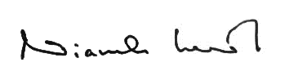
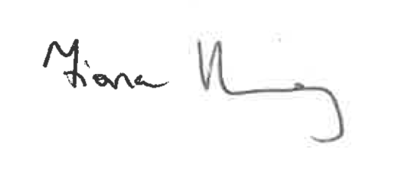
Kind Regards,

_________________________ ____________________________
Fiona Kearney, MSc MBS FACSLM Niamh Leonard, MCRN 15431
Laboratory Manager Clinical Lead for Mortuary Services

